Platform model

# 1 System description

Model of the platform. Based on the mechanic equation, this model calculates the speed of the car and the braking.

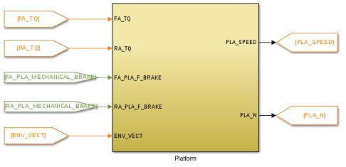

# 2 System organization

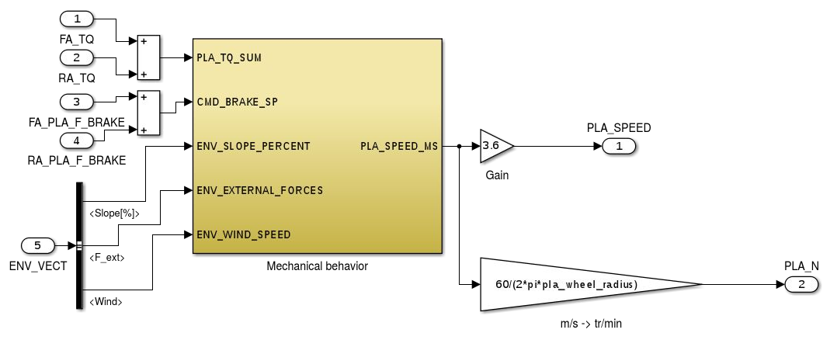

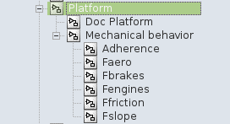

Model browser

# 3 Signals and parameters

## Inputs

|  |  |  |
| --- | --- | --- |
| Name | Description | Note |
| FA_TQ | Torque to wheel from the front axle |  |
| RA_TQ | Torque to wheel from the rear axle |  |
| FA_PLA_F_BRAKE | Force set point of mechanical brake of front axle | In N |
| RA_PLA_F_BRAKE | Force set point of mechanical brake of front axle | In N |
| ENV_VECTOR | Environment data, includes:   * Slope (%) * External forces (N) * Wind speed (m/s) | Bus signal |

## Outputs

|  |  |  |  |
| --- | --- | --- | --- |
| Name | Description | Note | Destination |
| PLA_SPEED | Car speed | In km/h | Driver |
| PLA_N | Wheel speed | In RPM | Command, front axle, rear axle |

## Parameters

### Native

|  |  |  |  |  |  |
| --- | --- | --- | --- | --- | --- |
| Name | Type | Unit | Description | Source | Linked to |
| pla_csat | Var | - | Static friction coefficient | Continental |  |
| pla_equivalent_weight | var | kg | Car equivalentweight | BEI N7 2014 |  |
| pla_f | var | - | Friction coefficient | Continental |  |
| pla_initial_speed | var | m/s | Initial speed | Case specific |  |
| pla_k | var | - | Friction coefficient | Continental |  |
| pla_kaero | var | - | Cx of the car | Continental |  |
| pla_max_f_brakes | var | N | Maximum brakes force | Continental |  |
| pla_wheel_radius | var | m | Wheel radius (includes tire deformation) | BEI N7 2014 |  |

### Inherited

None

# 4 Subsystems description

Mechanical behavior:

Based on Newton’s second law to calculate the car speed. Each force is in a separate subsystem. Based on the BEI N7 2014 model, only the friction and adherence have been modified.

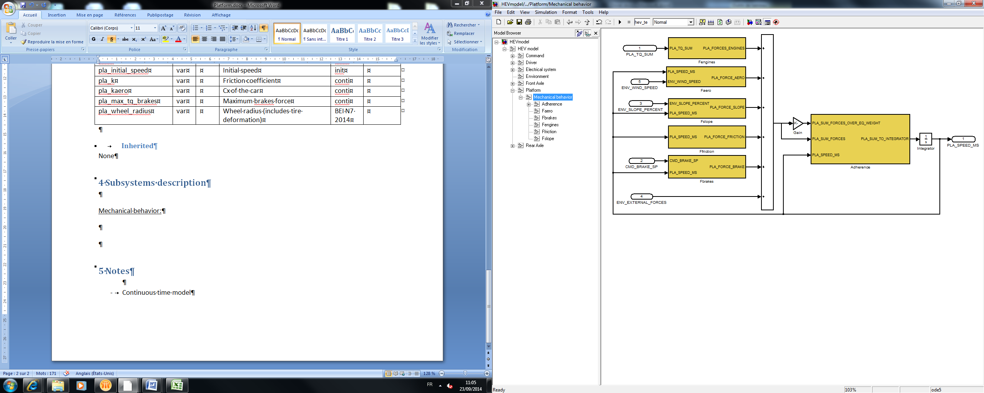

Fengines:

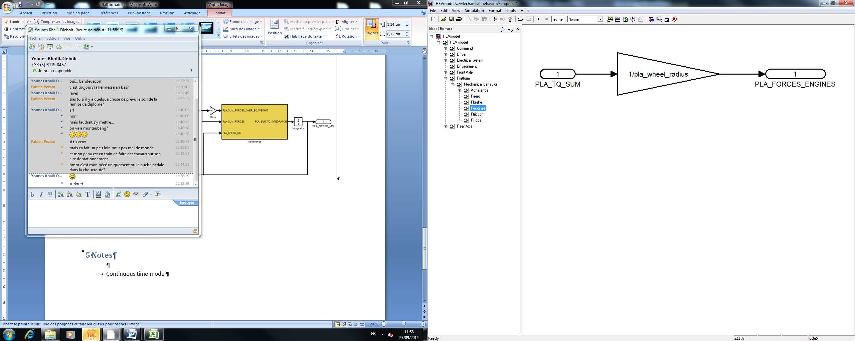

Faero

Aerodynamic resistance.

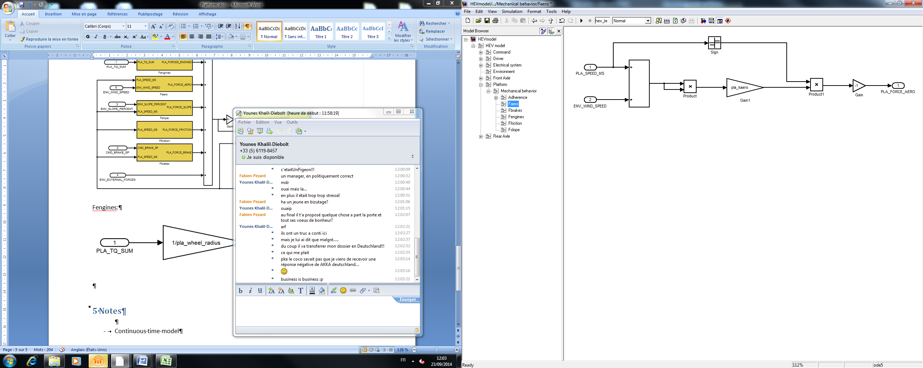

Fslope

Effect of a slope.

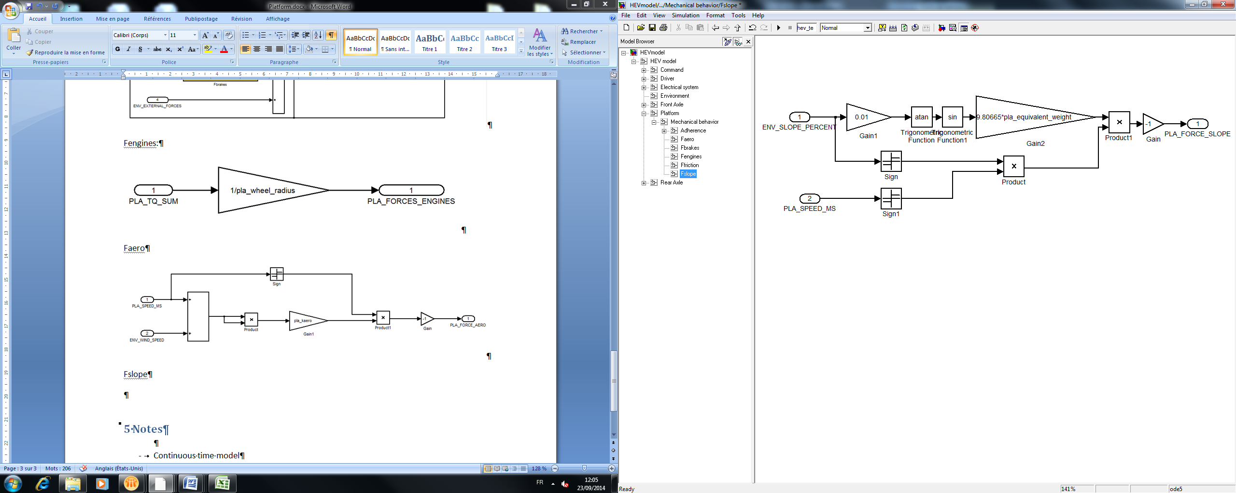

Ffriction

Friction forces.

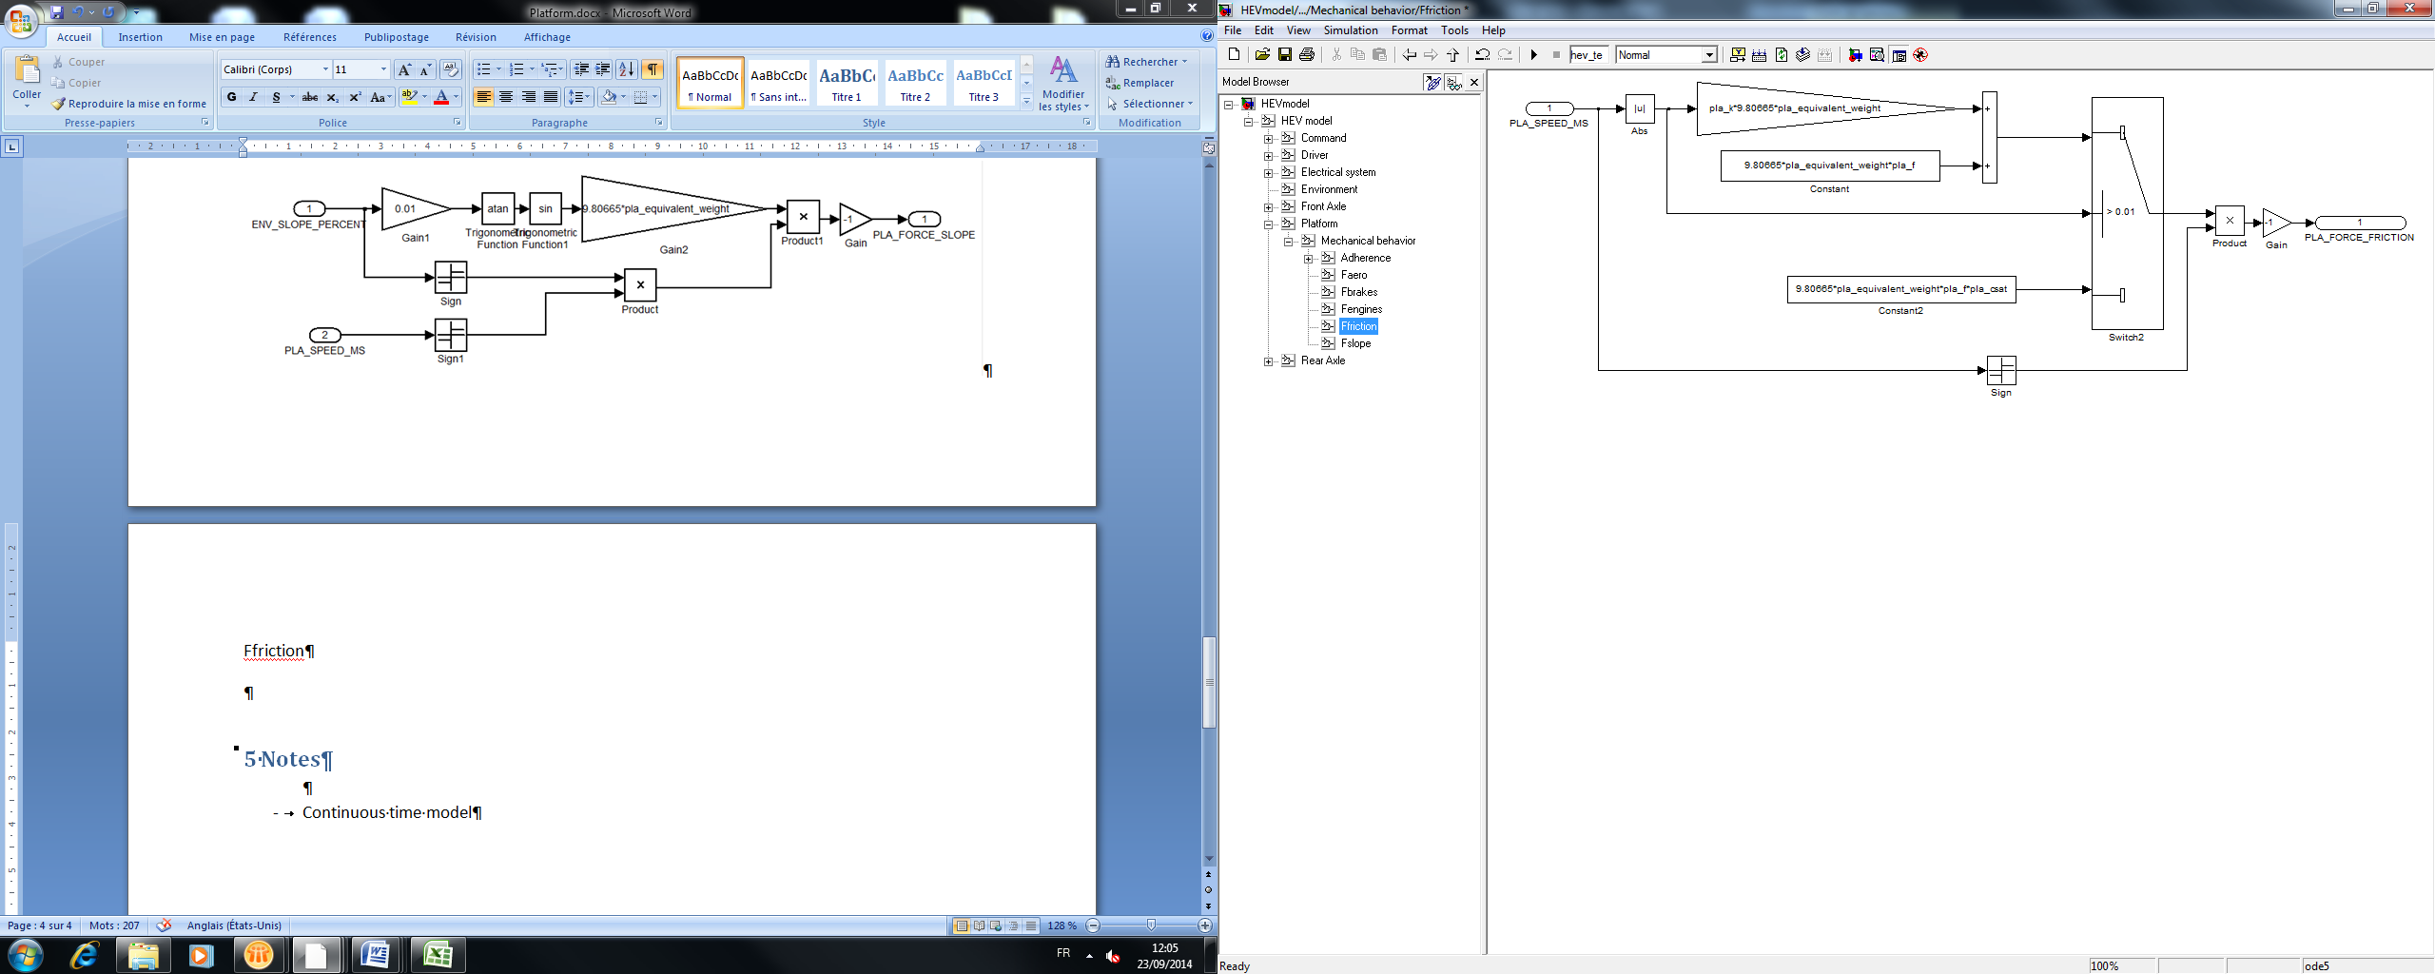

Fbrakes

Brakes system.

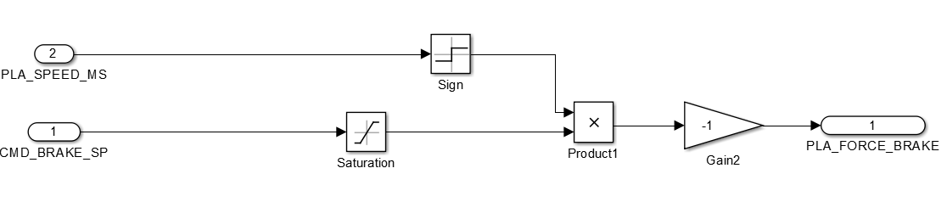

Adherence

Adherence of the car, preventing from moving.

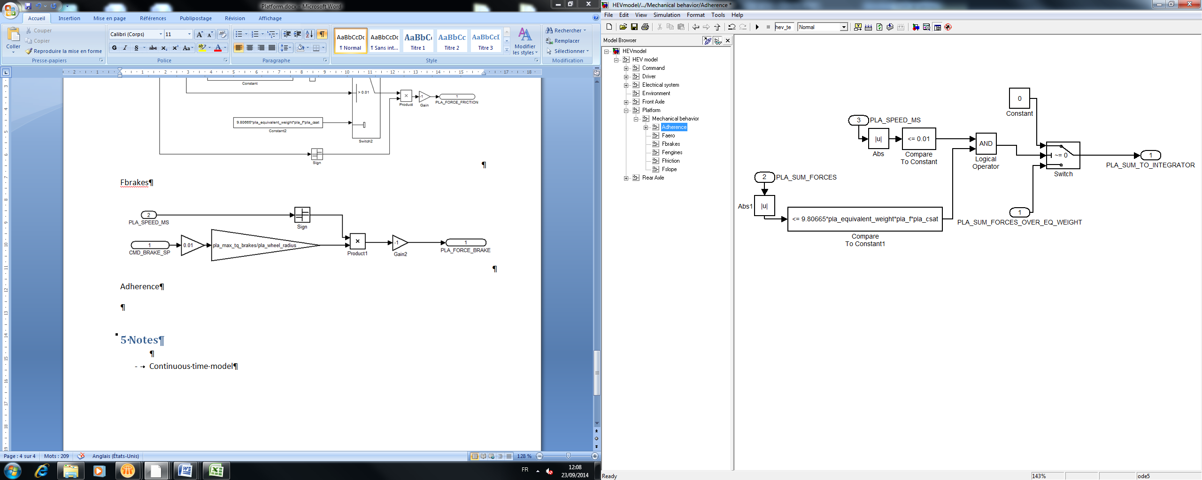

# 5 Discrete model

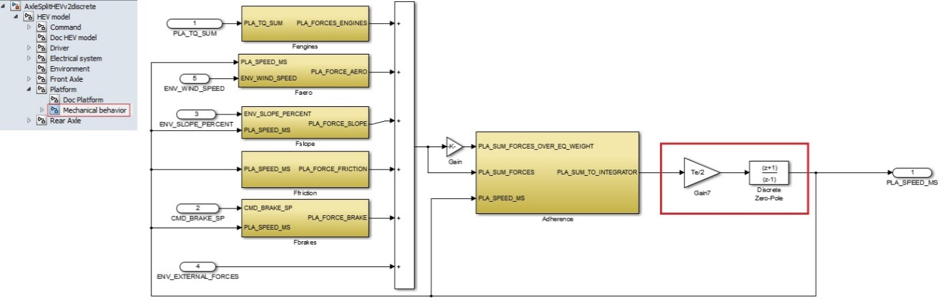

Same inputs, outputs and parameters. The only changes are in the red square.

See part 5 (“Discrete model”) of the document “HEV model” to know how are made the discrete blocs.